Title (lowercase, Calibri, bold, 14 pt, centred)

Authors (bold, 10 pt, centred). Example: A. Oliveira (1), S. Moreira (2) and J. Duarte (3)

1. Affiliation (institution, city, country) and e-mail address of the first author
2. Affiliation (institution, city, country) of the second author
3. …

**Abstract:** English abstract with a maximum of 150 words in Calibri font, size 10 pt and justified text. The inner and outer margins of the section between the title and keywords must be 3.5 cm and 3.0 cm, respectively.

**Keywords:** word 1, word 2, word 3, word 4, word 5

1. Guidelines

Extended abstracts may be written in Portuguese, Spanish or English.

Documents must be in Word format and submitted through the EasyChair platform (the file size must not exceed 50 MB) by May 30th, 2025.

All papers will undergo a prior scientific evaluation by a panel of experts, who may suggest minor revisions, require significant changes, or even reject them if their scientific quality is deemed insufficient.

Failure to follow the publication guidelines may also lead to rejection.

Papers must not exceed four pages, including figures, tables, references and acknowledgements. Pages must be in A4 format, with mirrored margins: 2 cm for the top, bottom and outer margins, and 2.5 cm for the inner margin.

The main body of the text must be written in Calibri font, size 10 pt, formatted in two columns of 7.75 cm each, with single line spacing and 5 pt spacing before each paragraph.

Chapter and subchapter titles must be numbered. Chapter titles should be written in uppercase, bold, 11 pt; whereas subchapter titles should be in lowercase, bold, 10 pt. A 10 pt spacing should be applied before each title.

1.1. Figures and tables

Figures may be in colour (or black and white) and should fit the width of one or two columns. In the text, references to figures must be written in full (e.g., “… in Figure 1” or “… (Figure 1)”).

The text included in each figure should be appropriately sized to ensure readability when printed in A4 format (100% zoom).

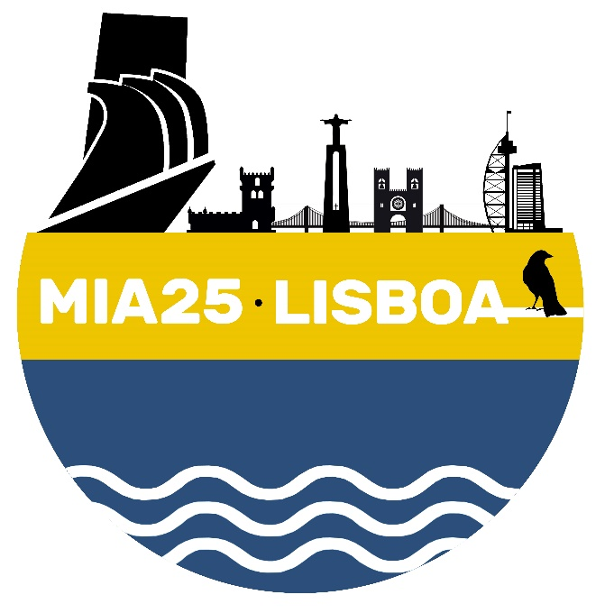

Figure 1. Figure captions (maps, diagrams, photographs, etc.) must be written in italics, size 8 pt, and justified alignment.

Tables must be numbered independently using Roman numerals (Table I, Table II, etc.). Table captions must be placed above the corresponding table. The text format and width should follow the same guidelines as for figures.

Acknowledgements

The title of this section must be written in lowercase, bold, 11 pt.

References

Citations in the text must include the author's surname followed by the year of publication, *e.g.* McLane (1995). For two authors, the reference should be Vinhas and Rodrigues (2023), and for more than two authors, it should be Santos *et al.* (2020).

The list of references should appear at the end of the text, in alphabetical order of the first author, with all authors identified.

References must be written in Calibri font, size 9 pt, with a 3 pt spacing before each one and a special hanging indentation of 0.5 pt.

Examples:

McLane, M. (1995). *Sedimentology*. Oxford University Press, New York, 423 p.

Santos, A.I., Oliveira, A., Carinhas, D., Pinto, J.P., Zacarias, N. e Freitas, M.C. (2020). The acoustic properties of in-situ measured suspended sediments and their implications on concurrent ADCP response – Case studies of the Portuguese inner shelf. *Marine Geology*, 419:106079.

Short, A.D. e Masselink, G. (1999). Embayed and Struturally Controlled Beaches. In: Short, A.D. (ed.), *Handbook of beach and shoreface morphodynamics*. John Wiley & Sons, Chichester, pp. 230-250.

Vinhas, A. e Rodrigues, A (2023). A cobertura sedimentar da plataforma continental do barlavento algarvio: análise sismo-estratigráfica e evolução recente*. Livro de resumos do XI Congresso Nacional de Geologia*, Coimbra, pp. 173-174.